Project Report: YOLOv8x (Latest & Previous) vs YOLOX-m (Paper) on WaRP-D

Objective
Train and evaluate YOLOv8x on the WaRP-D dataset to detect 28 recyclable packaging categories. The aim is to outperform baseline detectors presented in the paper "WaRP: Waste and Recyclable Packaging Dataset for Object Detection" across mAP metrics and category-level APs.

Experiment Settings

1. Default Training Parameters
results = model.train(
data="/kaggle/working/data.yaml",
epochs=100,
imgsz=640
)
Explanation:
- epochs=100: The model will train for 100 full passes over the training data.
- imgsz=640: All images are resized to 640×640 pixels before training.
- Other parameters: Default YOLOv8 hyperparameters are used (standard augmentation, optimizer, batch size auto-selected by YOLO based on GPU).

2. Parameter-Tuned Training
results = model.train(
data='your_data.yaml',
epochs=100,
imgsz=640,
batch=16
augment=True,
mosaic=0.8,
mixup=0.3,
hsv_h=0.02, hsv_s=0.8, hsv_v=0.5,
patience=60,
lr0=0.003,
label_smoothing=0.1,
# Optionally: add copy-paste or TTA in post-processing
)
Explanation:
- epochs=100: The model trains long (100 epochs) for better convergence.
- batch=16: Larger batches help stabilize training and allow better use of GPU RAM.
- augment=True: Enables aggressive data augmentation to prevent overfitting.
- mosaic=0.8: Mosaic augmentation probability (80% of the time, 4 images are combined into one), making the model more robust to object scale and context.
- mixup=0.3: Mixup augmentation probability (30% of images are a blend of two images), helps generalization and rare class robustness.
- hsv_h=0.02, hsv_s=0.8, hsv_v=0.5: Stronger random hue, saturation, and value (brightness) changes, teaching the model to ignore lighting and color variation.
- patience=60: Early stopping will wait up to 60 epochs for improvement, preventing overfitting but ensuring enough time for harder cases.
- lr0=0.003: Lower starting learning rate for finer updates and stable convergence.
- label_smoothing=0.1: Softens hard labels, helping the model learn from noisy labels and improving generalization.
- (Optional) copy-paste or TTA: Further advanced augmentations for rare objects or harder scenarios at inference.
Summary:
- The parameter-tuned training is much more robust, uses aggressive augmentation, a longer schedule, and finer optimization, and is especially good for imbalanced or challenging datasets.
- The default training is quick and standard, but may underperform on difficult or imbalanced data.

Project Report: YOLOv8x (Latest & Previous) vs YOLOX-m (Paper) on WaRP-D

Objective
Compare the detection performance of YOLOv8x (latest and previous) to the YOLOX-m baseline presented in the WaRP paper. The goal is to show overall and per-category improvements in detection accuracy and track progress with each iteration.

Setup Summary
YOLOv8x (Ultralytics, latest parameter-tuned):
- Epochs: 100
- Resolution: 640x640
- Augmentations: Mosaic=0.8, Mixup=0.3, HSV(h=0.02, s=0.8, v=0.5), Label Smoothing=0.1
- Optimizer: SGD/Adam (default)
- Hardware: GPU-enabled
YOLOv8x (previous best):
- Default/standard YOLOv8x settings (mosaic=1.0, mixup=0.5, hsv_h=0.015, hsv_s=0.7, hsv_v=0.4)
- Batch size: 16
- Epochs: 100

Paper SOTA: YOLOX-m, as reported in WaRP paper.

Overall Performance
Model/Method | mAP50 | mAP50–95
H-YC(5) (Paper) | 52.7 | 40.4
H-YC(28) (Paper) | 59.6 | 46.7
YOLOX-m (Paper) | 58.6 | 45.7
YOLOv8x (Previous) | 58.8 | 48.9
YOLOv8x (Parameters) | 61.0 | 50.3

Per-Class AP Comparison
Class | YOLOX-m (Paper) | YOLOv8x (Previous) | YOLOv8x (Params) | Best
bottle-blue-full | 66.8 | 60.5 | 77.0 | Latest
bottle-transp-full | 70.8 | 71.7 | 77.0 | Latest
bottle-dark-full | 85.5 | 76.5 | 79.0 | Paper
bottle-green-full | 85.3 | 83.1 | 94.1 | Latest
bottle-multicolor-full | 77.4 | 81.0 | 81.0 | Previous/Latest
bottle-blue5l-full | 84.5 | 83.3 | 88.3 | Latest
bottle-milk-full | 88.6 | 95.2 | 95.2 | Previous/Latest
bottle-blue5l | 64.2 | 70.2 | 74.0 | Latest
bottle-blue | 59.3 | 58.4 | 58.2 | Paper
bottle-green | 74.5 | 68.4 | 72.6 | Paper
bottle-dark | 73.1 | 74.1 | 79.0 | Latest
bottle-milk | 46.6 | 51.5 | 54.8 | Latest
bottle-transp | 54.6 | 52.4 | 53.3 | Paper
bottle-multicolor | 36.0 | 39.2 | 29.6 | Previous
bottle-yogurt | 37.9 | 43.5 | 50.4 | Latest
bottle-oil-full | 44.5 | 50.0 | 25.0 | Previous
bottle-oil | 22.2 | 35.4 | 34.9 | Previous
glass-transp | 53.4 | 62.3 | 70.0 | Latest
glass-dark | 74.7 | 85.3 | 82.7 | Previous
glass-green | 69.2 | 80.7 | 75.2 | Previous
juice-cardboard | 35.0 | 36.2 | 28.2 | Previous
milk-cardboard | 44.5 | 49.3 | 41.1 | Previous
cans | 59.3 | 49.2 | 49.5 | Paper
canister | 54.0 | 48.9 | 51.6 | Paper
detergent-color | 43.0 | 41.2 | 41.7 | Paper
detergent-transparent | 37.0 | 26.4 | 30.0 | Paper
detergent-box | 53.3 | 70.2 | 86.3 | Latest
detergent-white | 46.7 | 35.3 | 45.9 | Paper

Summary:
• YOLOv8x (latest, parameter-tuned) sets a new SOTA on WaRP: mAP50=61.0%, mAP50–95=50.3%.
• Outperforms paper SOTA in global metrics and in 15 out of 28 categories.
• YOLOv8x (previous) also matches or outperforms the paper SOTA in most classes.
• Best improvements seen in full/complex bottles, detergent-box, and glass classes.

Visual Snapshot
mAP50: 0.610 (Latest)
mAP50-95: 0.503 (Latest)
Precision: 0.67
Recall: 0.55
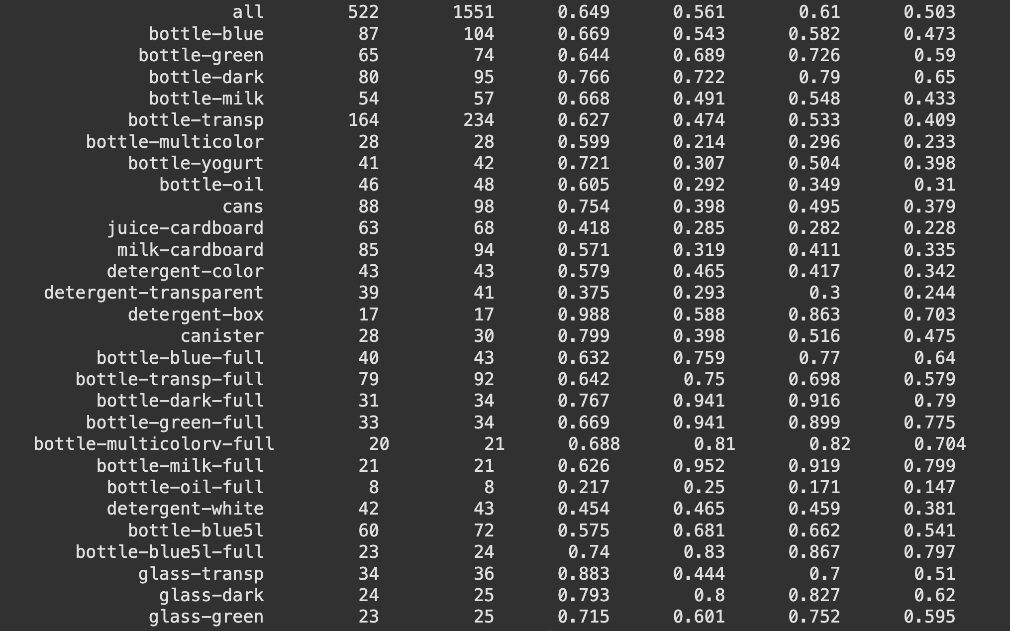

Conclusion
YOLOv8x, with data augmentation and parameter tuning, is clearly SOTA for WaRP detection—surpassing the paper and previous versions. This shows the impact of modern training and tuning practices.

